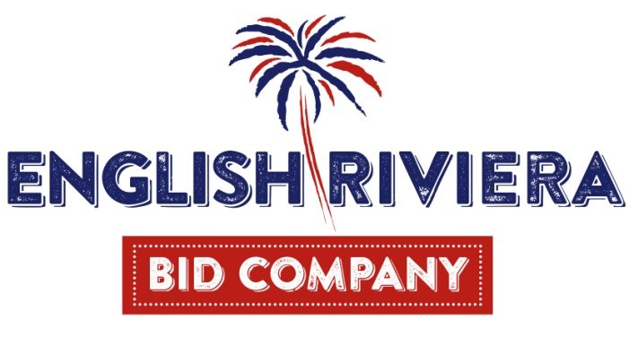
Company Membership Charter and Application Form
English Riviera Business Improvement District Ltd
(A company limited by guarantee, Registration No 10237792)
In signing this document you agree to become a member of the above not for Profit Company, to abide by the following charter and to agree your liability of no more than £1 in the event of the company being wound up.
Every BID levy payer is eligible to become a member of the company providing he/she has paid their due levy in the allotted time. They must have paid the current years levy by 31st March, and in future years must have paid the previous year’s levy as well.
In order to become a member, a levy payer must complete the appropriate registration form.
Where a levy payer has multiple hereditaments he/she is entitled to one membership.
All positions, except chair, are voluntary and there will be no remuneration except for any agreed, reasonable and authorised expenses incurred on legitimate company business.
Members must work in the best interests of the company and its objectives in ensuring the delivery of the agreed Business Plan. Rules set out in the BID Company Memorandums & Articles of Association apply. Members are entitled to attend company member’s business meetings and cast any vote that is requested.
Abusive activity will not be tolerated including online postings. Members must declare any conflicts of interest.
Except for the first year, members will not be able to stand for the position of Director unless they have been in membership for at least 12 months.
Members are required to treat all communications and discussions of and relating to company business, verbal and written as confidential and not to be discussed, distributed or used in any way unless agreed by the Company Board.
Membership of the Company can be withheld or withdrawn for any levy payer who does not comply to this charter. Decisions on membership will be taken by the Board of Directors and will be final.
Membership applications will be confirmed following the monthly Board meeting. Applicants should allow up to six working weeks for their application to be processed.

I have read and herby accept all elements of the ERBID membership charter.
Signature

Print Name

Business Name

Position in Business

Date

Nature of Business

Address of Business

Postcode

Email Address

Phone Number

Mobile Number

Contact Name

Correspondence address (if different from business address)

Please return your signed registration form to: Operations Executive, English Riviera BID Company, 5 Vaughan Parade, Torquay, Devon, TQ25JG.

